**Significant Concerns Affecting Western Maharashtra's Primary Agricultural Cooperative Societies**

**Ms. (Author1)**

Research Scholar **(Designation)**,

Annasaheb Magar Mahavidyalaya **(Institute)**, Hadapsar **(Place)**

**Dr. (Author2)**

Assistant Professor **(Designation)**

Shardabai Pawar Mahila Mahavidyalaya **(Institute)**, Shardanagar **(Place)**

**Dr. (Author3)**

Associate Professor **(Designation)**

Anekant Institute of Management Studies **(Institute)**, Baramati **(Place)**

*.*

***Abstract:*** *Primary Agricultural Credit Society is actually organized at the grass-roots level a village or a group of small villages. It is the basic unit which deals with rural credit to farmers for meeting their financial requirements. For the development of agricultural sector and allied activities adequate and timely finance are essential. But many financial problems are cropping up in the process of development of co-operative system. In this paper an effort is made to study critical issues in agricultural cooperatives. The research is empirical in nature. Western Maharashtra is selected as research area. The Chairman and Secretary of selected PACS are respondents. Interviews are conducted to gather primary data. The findings and suggestions are presented to highlight the significant concerns of PACS and strengthen the performances of Agricultural Cooperatives.*

***Key Words*:** *Primary Agricultural Cooperatives Societies*

**Introduction:** Cooperative businesses are an important part of the Western Maharashtra’s economy and are particularly prevalent in the agricultural sector. Cooperatives operate under a business model that generates unique challenges in finance management, governance, strategy and communication. These unique challenges and the prevalence of cooperatives in Indian agriculture have encouraged research and education efforts by agricultural economists since the early 1900’s. Agricultural cooperatives were formed under the Co-operative Credit Societies Act, 1904 to facilitate the collection of agriculture output from small and marginal farmers. Co-operative model has long been the dominant form of farmer output collection in Maharashtra; however, the experience with cooperative model leads to many limitations that prevent effective collective action. Most of the Primary Agricultural Credit Societies (PACS) in Maharashtra have kept their political agenda ahead of the economic benefits of their entities. As a result, the

cooperative model point to many limitations that prevent effective collective action. A few key challenges faced by small and marginal farmers are access to investments, technological advancements, and efficient inputs and markets. A large number of these cooperatives in the Maharashtra currently are in a state of financial crisis and are growing increasingly dependent on state subsidy for survival. The Government of Maharashtra has identified PACS at grass root levels as the most appropriate institutional form to mobilize farmers and build their capacity to collectively leverage their production and marketing strength. This paper is an output of an empirical research carried out to study external environmental and strategic issues affecting agricultural cooperatives. This paper throws light on finance, governance and communication issues affecting agricultural cooperatives. The focus of this study is to identify new cooperative development issues affecting agricultural cooperatives.

**Review of Literature:** The interest of agricultural economists in agricultural cooperatives is understandable and appropriate. The agricultural cooperative credit business model creates unique challenges and economic questions which agricultural economists are positioned to address. In addition, since agricultural cooperatives are owned by and designed to benefit producers, cooperative related research has the potential to benefit a large number of farmers. Almost 72015,000 farmers are members of agricultural marketing cooperatives (Joshi et al., 2019). There have also been a number of literatures and research based efforts to identify challenges, critical issues and success factors for agricultural cooperatives. The objective of this paper is to summarize current challenges and needs within the cooperative community.

**Research Methodology:**

Research Method in a nut shell:

1. Philosophy of Research: Empirical
2. Nature of Research: Descriptive
3. Approach: Cross sectional Quantitative and Positivist
4. Data Type: Primary and Secondary
5. Data Collection Tool: Interview Diary
6. Data Collection Method: Survey
7. Participants: Chairman and Members of selected PACS
8. Sampling Method: Convenience Sampling

**Question:** What are the critical issues for agricultural cooperatives?

**Research Area**: The present study examines the selected critical issues faced by PACS in Pune, Nasik, Satara, Sangli, Solapur, Kolhapur and Ahmednagar. These are 7 districts of Western Maharashtra.

**Research Objectives:** Broadly three aspects are examined;

1. To study external environmental and strategic issues affecting agricultural cooperatives.
2. To study finance, governance and communication issues affecting agricultural cooperatives.
3. To study new cooperative development issues affecting agricultural cooperatives.

**Data Collection:** The data is obtained from both primary and secondary source.

Three secondary sources are referred:

1. Reports from National Federation of State Cooperative Banks Ltd.
2. Report of the expert committee of NABARD to examine three tier short term cooperative credit structures.
3. National Co-operative Union of India, Indian Co-operative Movement Statistical Profile-2018

Primary data is collected from Interview with Chairman of selected PACS. The challenges and issues for cooperatives were identified through a two-stage modified Delphi survey process and a face-to-face focus panel discussion. A Delphi survey is a multi-stage expert survey in which the opinions and information from the first stage are used to refine the second and subsequent stages. The basis of selection of PACS is the performance of PACS. Top 10 performing PACS from each strata of research area are selected. To identify top 10 PACS, data from latest report of State of Maharashtra's Agri-business and Rural Transformation Program Project (SMART) is referred. For this study 1 Chairman of each PACS was approached. There are 7 districts in research area and top 10 PACS equates to selection of 70 PACS. This leads to an approach to population of 70 respondents. 28 respondents i.e. 41% consented for the survey and spared their valuable time for the personal interview with researchers. 2 respondents requested to delete their responses. This means the Sample Unit for this study is 26 Chairpersons. Significant representation of each district as strata is observed. This signifies that sample harmoniously represents the population.

**Research Design:** The time frame referred for collecting secondary data is 5 years viz. Accounting Year starting from 2015 to 2020. Researchers have identified 3 critical factors from literature review. These factors are identified as impact factors which lead to inconsistency. Clearly a purposive approach to research design is followed.

**Method of Data Analysis:** Findings of each personal interview with selected sample are noted in research diary. All findings are then grouped based on homogeneity. The presentation of this data is in the form of Bar Charts based on percentage of homogeneity.

Limitations: Any comparison is a construction in the sense that it discerns which elements or segments of social reality are to be related to one another and along what dimensions. As a construction, comparison thus helps create an ordered perception of this reality, i.e. an organized way to see it in one way rather than in many other alternative ways. Therefore, it should be reflected on, brought into the sphere of awareness, rather than deployed as if it were an unproblematic and self-evident mode of analysis. Furthermore, since comparison organizes perception in one way rather than another, one should also be conscious of the kind of order it yields.

Scope: PACS’s are encountered with a lot of problems. The present study is an attempt to assessing financial performance of PACS’s in a holistic approach encompassing both quantitative as well as qualitative variables relating to the societies.

**Data Analysis and Interpretation:**

**Objective 1:** To study external environmental and strategic issues affecting agricultural cooperatives.

**Interpretation & Findings:**

The respondents reported that a variety of issues external to PACS in Western Maharashtra are impacting them (Figure 1). Volatility of commodity and input markets was perceived as the most important issue. The respondents indicated that recent market Public policy, global competition, industry competition and market concentration were all perceived as extremely important or very important issues. Consumer preferences were rated as “extremely important” by nearly a third of the respondents.

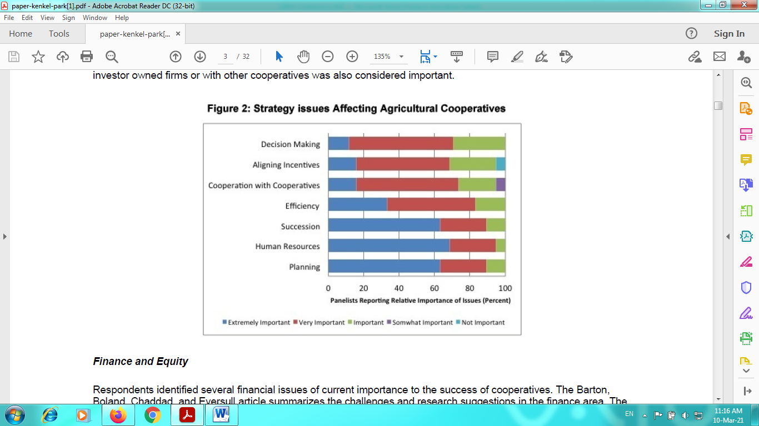

**Interpretation & Findings:**

The respondents identified a number of challenges and issues which are inherently important to cooperatives, and must be dealt with in the context of the external environment in which they operate. These outside forces impacted the collective perception of the strategic issues facing cooperatives (Figure 2). Almost 90% of the cooperative leaders viewed the need for effective strategic planning as an extremely or very important issue. Aside from planning, human resource issues dominated the strategy area. The succession of management and key personnel, attracting and maintaining high quality personnel, and aligning the incentives of managers and employees with member interest all received high importance ratings. A third of the respondents viewed gaining efficiency and maintaining viability in their market segments as an extremely important issue, while 12% gave extreme importance to the cooperative’s ability to make effective, timely decisions. The ability of the cooperative to pursue alliances with investor owned firms or with other cooperatives was also considered important.

**Table 1 ANOVA Tables of Elbow Joint and Shoulder Joint**

|  |  |  |  |  |  |  |
| --- | --- | --- | --- | --- | --- | --- |
|  | | **Sum of Squares** | **df** | **Mean Square** | **F** | **Sig.** |
| **Elbow Joint** | **Between Groups** | 113.86 | 2 | 56.93 | .183 | 0.83 |
| **Within Groups** | 8389.60 | 27 | 310.72 |  |  |
| **Shoulder Joint** | **Between Groups** | 153.26 | 2 | 76.63 | .264 | 0.77 |
| **Within Groups** | 7851.40 | 27 | 290.79 |  |  |

**Objective 2:** To study finance, governance and communication issues affecting agricultural cooperatives.

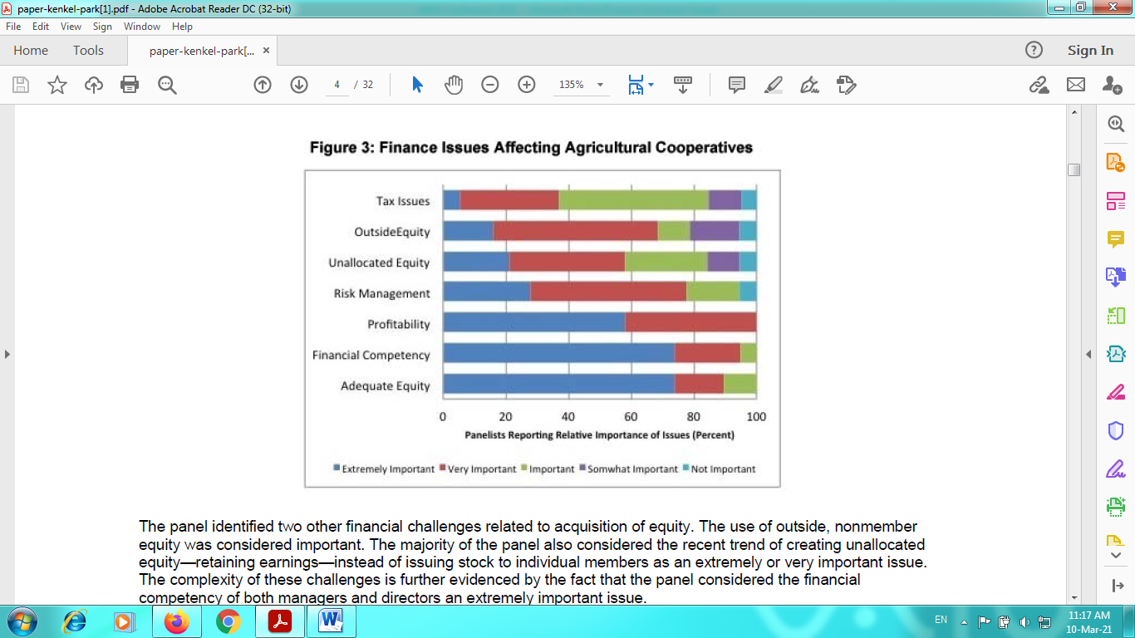

**Interpretation & Findings:**

Respondents identified several financial issues of current importance to the success of cooperatives. They indicated that acquiring and maintaining adequate equity was the most critical challenge. This issue is related to the features of the cooperative business model since cooperatives often create equity out of the profit stream and simultaneously manage systems to return—redeem—that equity to members. It is therefore not surprising that maintaining sufficient and consistent profitability and risk management were also considered key issues. The respondents identified two other financial challenges related to acquisition of equity. The use of outside, nonmember equity was considered important. The majority of the respondents also considered the recent trend of creating unallocated equity—retaining earnings—

instead of issuing stock to individual members as an extremely or very important issue. The complexity of these challenges is further evidenced by the fact that the respondents considered the financial competency of both managers and directors an extremely important issue.

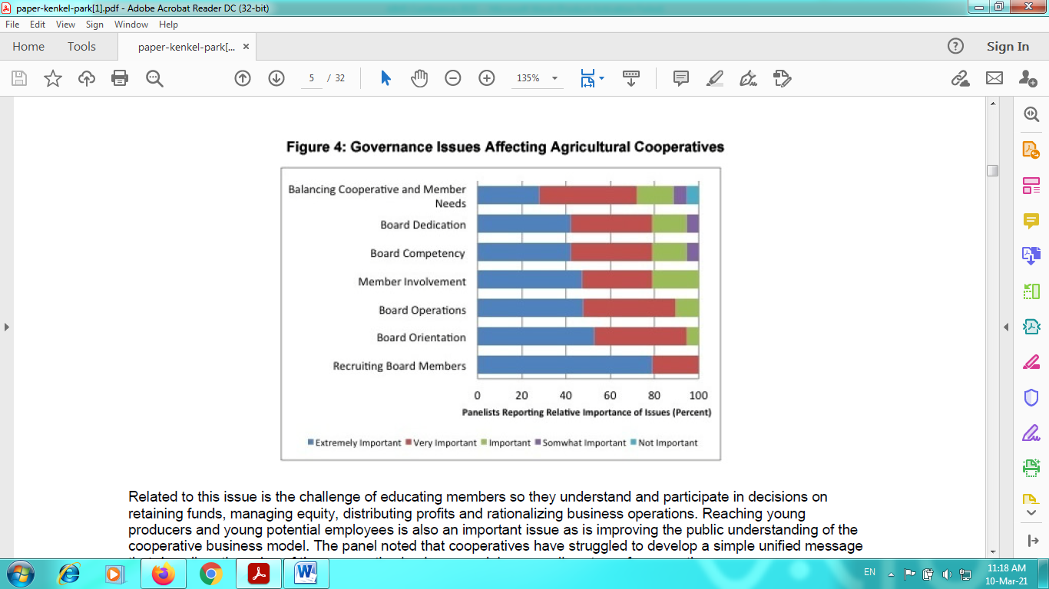

**Interpretation & Findings:**

The fact that agricultural cooperatives are governed by producer-members is both a key strength and a key challenge for cooperatives. The key governance challenge (Figure 4) is that of identifying and recruiting directors with the essential mix of skills. Member involvement in a cooperative—another key issue—often relates to their access to board members or interest in running for the board. Other governance issues identified by the panel were related to the effectiveness and performance of the board of directors. The addition of outside, non-member directors has been a recent development in agricultural cooperatives, and according to the panel, is an important issue facing modern cooperatives.

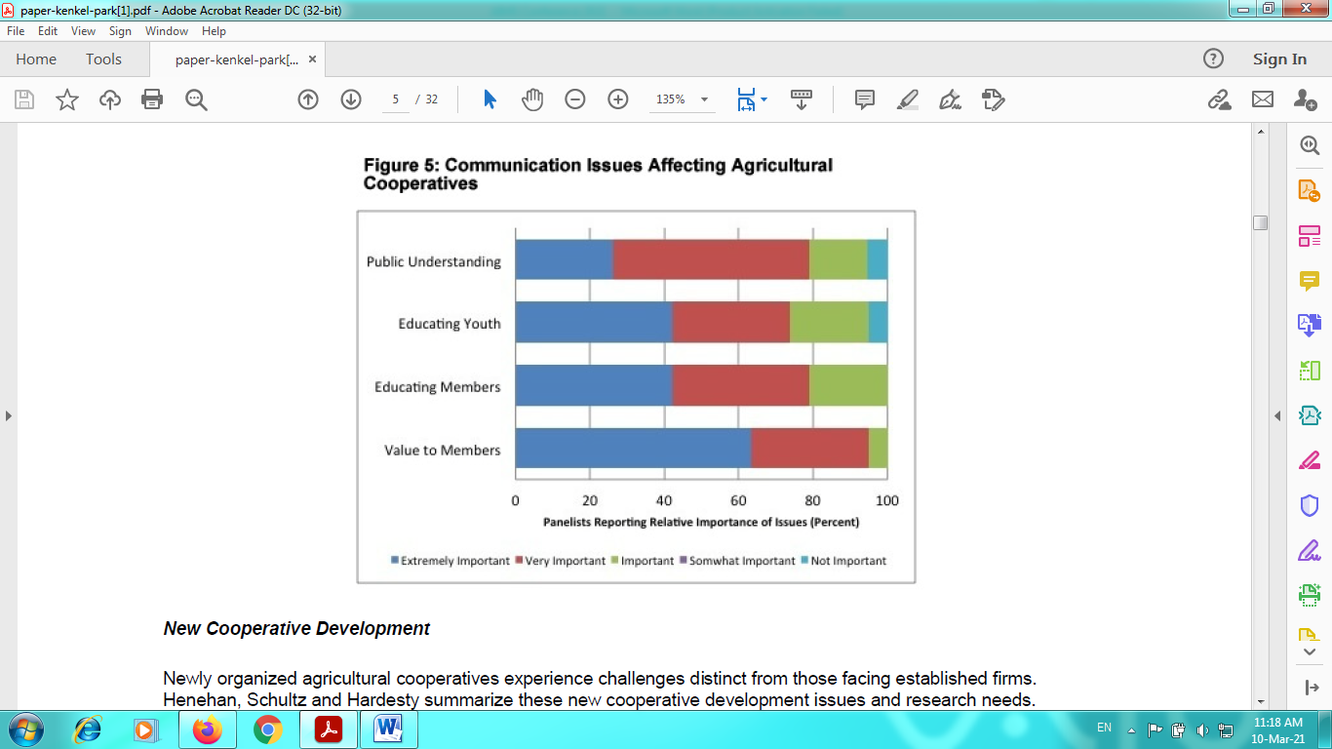

**Interpretation & Findings:**

The respondents identified a number of issues relating to communications (Figure 5). All businesses, including cooperatives are formed to create and deliver value to their customers and owners. The cooperative member is both user and customer and this creates tension in generating and allocating economic benefits. This also creates unique challenges in communicating the value of the cooperative to both its members and to the general public. Communicating the value of the cooperative to its member owners was the most critical communication challenge identified. Cooperatives create value through the prices they provide members, access to the market place, unique services provided, counteracting market power, and of course, the financial return created at the cooperative level. Communicating this complex value package, particularly to large producer-members, was identified as a key issue. Related to this issue is the challenge of educating members so they understand and participate in decisions on retaining funds, managing equity, distributing profits and rationalizing business operations. Reaching young producers and young potential employees is also an important issue as is improving the public understanding of the cooperative business model. The respondents noted that cooperatives have struggled to develop a simple unified message that describes the value of the cooperative business model across all sectors of cooperatives.

Objective 3: To study new cooperative development issues affecting agricultural cooperatives.

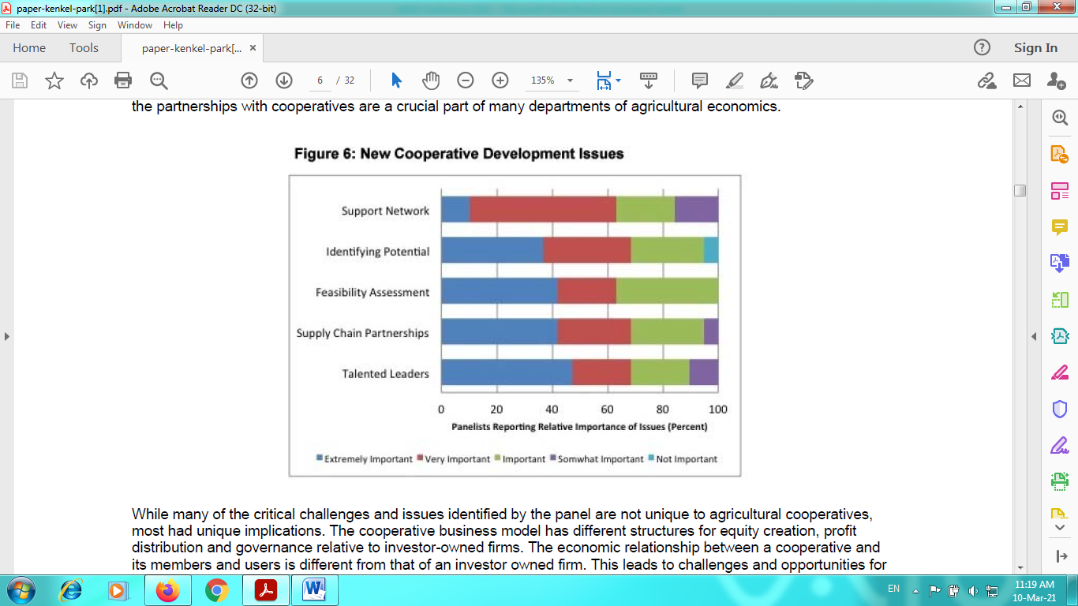

**Interpretation & Findings:**

Newly organized agricultural cooperatives experience challenges distinct from those facing established firms. Cooperative membership—and therefore ownership—is dynamic and is limited to the current users of the business. Thus, founding members of a cooperative may have a very different perception of the firm’s value in comparison with future generations. Surprisingly, the respondents indicated that many issues facing new cooperatives are similar to those described as facing established cooperatives (Figure 6). Acquiring significant equity, and identifying and attracting knowledgeable leadership, are viewed as key impediments to the development of successful cooperatives. Other key issues facing new cooperatives include developing partnerships within the supply chain, and accurately forecasting demand and business feasibility.

The respondents commented that managers and board members of new cooperatives need linkages with their counterparts in established, successful firms.

**Conclusion:**

While many of the critical challenges and issues identified by the researchers are not unique to agricultural cooperatives, most had unique implications. The cooperative business model has different structures for equity creation, profit distribution and governance relative to investor-owned firms. The economic relationship between a cooperative and its members and users is different from that of an investor owned firm. This leads to challenges and opportunities for cooperative leaders and research questions for agricultural economists. The paper provides a summary and discussion of these issues. The paper discusses issues relating to strategy, finance, governance, communication and new cooperative development. It provides insights into how the unique business structure of agricultural cooperatives influences their relationship with producer members and their competitive environment.

**References:**

1. *Anil Kumar Soni, and Dr. Harjinder Pal Singh Saluja, “Role of Cooperative Bank in Agricultural Credit: A study based on Chhattisgarh, Vol No.1, Issue No.10, ISSN2277-1166.*
2. *Belshaw, H. (1931) The Provision of Credit with Special Reference to Agriculture. Auckland University Press, Cambridge.*
3. *Misra and Puri, Indian Economy, Himalaya Publishing House, 28th revised edition and updated edition-2010.*
4. *Statewise Basic Data of Primary Agricultural Cooperative Societies. http://nafscob.org/pacs_f.htm*
5. *Sonali, S. (2015) Growth of Primary Agricultural Cooperative Societies (PACS) in Maharashtra in the Post Reform Period. Journal of Extension Education, XX, 60-65.*